GT Username: sanne31@gatech.edu
Part 1. Data Preprocessing
Visualization of Each Class in each data partition in both datasets

Training Set – Class Label 0 Training Set – Class Label 1
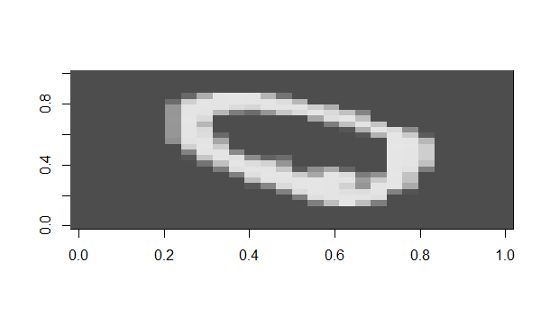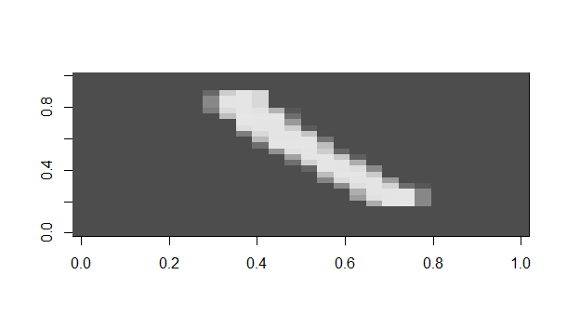

Training Set – Class Label 3 Training Set – Class Label 5
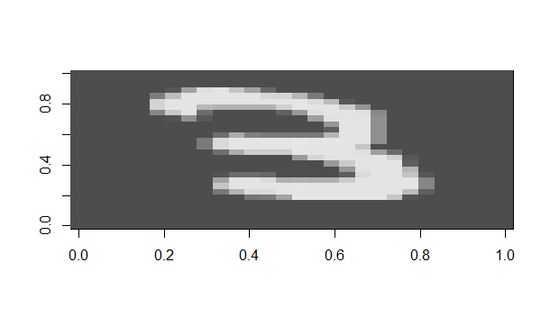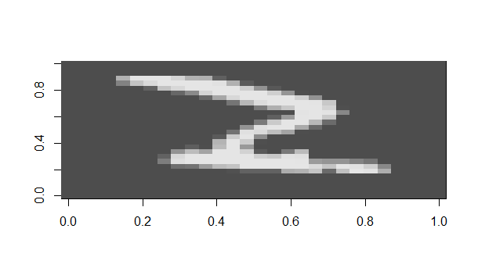

Testing Set – Class Label 0 Testing Set – Class Label 1
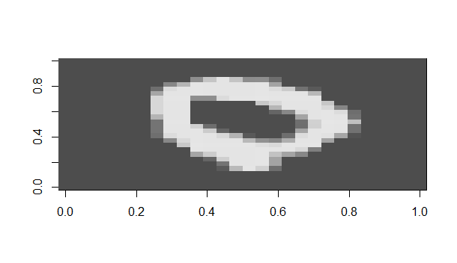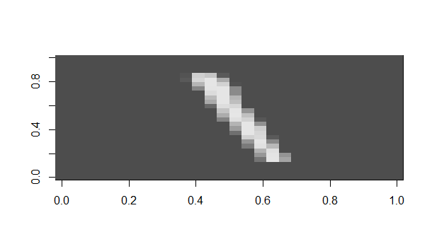
Testing Set – Class Label 3 Testing Set – Class Label 5
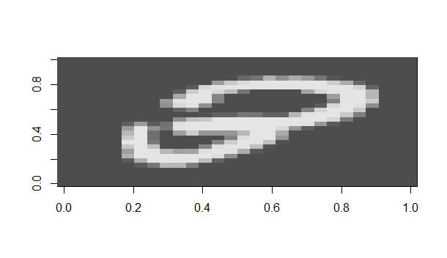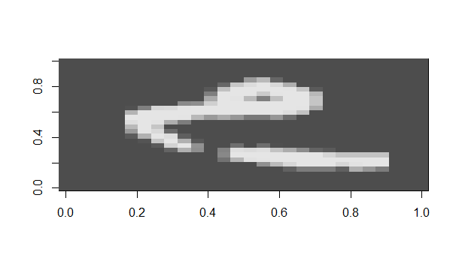
Part 2. Theory
Reference: https://web.stanford.edu/class/archive/cs/cs109/cs109.1166/pdfs/40%20LogisticRegression.pdf
https://www.cs.upc.edu/~marias/teaching/ml/1regression.pdf
Loss Function
$$L\left(θ\right)=\prod_{i=1}^{n}{σ{\left(θ^{T}x^{i}\right)}^{y^{i}}}⋅{\left[1-σ\left(θ^{T}x^{ⅈ}\right)\right]}^{\left(1-y^{ⅈ}\right)}$$
$LL\left(θ\right)=\sum_{i=0}^{n}{y^{i}\log{σ\left(θ^{T}x^{i}\right)}}+C,-y^{ⅈ}\log\left[1-σ\left(θ^{T}x^{ⅈ}\right)\right]$

- where x is the data point represented
- $Θ$ is the parameter vector
- y is the class label and y ϵ {-1,1}

Gradient Descent

$\frac{∂LL\left(θ\right)}{∂o_{j}}=\frac{∂}{∂θ_{j}}y\log{σ\left(θ^{T}x\right)}+\frac{∂}{∂θ_{j}}\left(1-y\right)\log\left[1-σ\left(θ^{T}x\right)\right]$ - derivative of sum of terms
= $\left[\frac{y}{σ\left(θ^{T}x\right)}-\frac{1-y}{1-σ\left(θ^{T}x\right)}\right]\frac{∂}{∂θ_{j}}σ\left(θ^{T}x\right)$ - derivative of log(f(x))
= $\left[\frac{y}{σ\left(θ^{T}x\right)}-\frac{1-y}{1-σ\left(θ^{T}x\right)}\right]σ\left(θ^{T}x\right)\left[1-σ\left(θ^{T}x\right)\right]x_{j}$ - chain rule + derivative of sigma
= $\left[y-σ\left(θ^{T}x\right)\right]x_{j}$ - cancellation of terms
= $\left[y-\frac{1}{1+ⅇ^{-\left(θ^{T}x\right)}}\right]x_{j}$ - final formula for gradient descent

Stochastic Gradient Descent
For a single sample at a time, the SGD update rule will become as follows:
$θ_{j}⇐θ_{j}-α\sum_{i=1}^{n}{\frac{1}{1+ⅇ\left(-y^{i}<θ,x^{i}>\right)}}$

Pseudo Code for Training a model using Logistic Regression
- Given α, { ( x^{i} , y^{i} ) }^{m}_{i = 1}
- Initialize a = ${\left\langle 1,⋯⋯1\right\rangle }^{T}$
- Perform feature scaling on the attribute
- Repeat until convergence
  - for each j = 0, ….., n;
    - a’_{j} = a_{j} + α $Σ_{i}\left(y^{ⅈ}-h_{a}\left(x^{ⅈ}\right)\right)x_{j}^{i}$
  - for each j = 0, . . . . . , n:
    - a_{j} = a_{j}
- Output a

Number of Operations
-- Each gradient descent update iteration requires 2n(d + 1) operations.
-- O(n²) – Big O notation

